**Kristen Bentley** 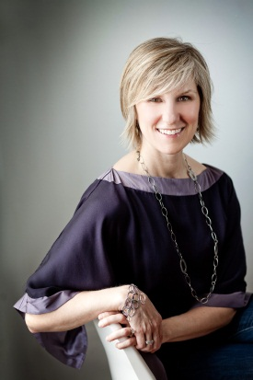

CPCC, Graduate of the Leader Program

Certified Physician Development Coach

Doctor of Optometry

22 Bridle Trail Midhurst, ON

L0L1X0 705.735.9975

[www.CoachingResource.ca](http://www.CoachingResource.ca)

I have a dream – My dream is for every human being to live and lead life, defined by them. I want people to know who they are and love who they are. I want them to discover what they are here for, where they are needed and I want them to authentically and powerfully answer the call. I want people to see how we are all similar in our humanity and celebrate the creative energy that stems from our diversity. When *we* come together from this place, *we* create a vibrant, thriving, peaceful life, workplace and world.

I truly believe that the Co-Active model is so much more than a coaching model. I believe that it is a powerful model for interpersonal relationships and part of my dream is for everyone to live in partnership – partnership with self, with others, with community and with something greater – to live co-actively – to create a co-active world.

As a result of this dream and passion, I truly believe that I will contribute immensely to the Front of the Room Leading Team for the public Core Curriculum courses and for organizations.

Work Experience:

* 1995-2011 Doctor of Optometry – Private Practice Owner – Barrie Vision Centre, Barrie, ON, Canada (self-employed – my husband and I started the company from scratch and built it to gross over 1 M annually. We sold it in Jan 2011)
* 1996 – 2008 Doctor of Optometry – Huronia Regional Centre – government home and institution for physically and mentally disabled adults
* 2011 – 2013 Professional & Personal Coach / CPCC May 2012. Areas of interest:
  + Healthcare (Leadership Development, Burnout Resiliency)
  + Executive Coaching
  + Relationships
  + Certification Coach/Mentor,
  + CTI Leadership Program Coach/Mentor
* 2012 - 2013 CTI Corporate – Healthcare Taskforce – co-leading with Jill Schichter
* 2012 - 2013 Workshop co-leader – various topics in and outside Healthcare
* 2012 - 2013 CTI Community Development – Toronto Ambassador

Education Experiences:

* 1995 University of Waterloo – School of Optometry – Awards and recognition for Clinical Excellence and Academic Proficiency
* 2011 – 2012 CTI – Core Curriculum, Business Builder, Certification, Leadership, Assisted Core Curriculum
* 2011 – 2012 Physician’s Coaching Institute – Certified Physician Development Coach
* 2012 SDI - Strengths Deployment Inventory - Certified Relationship Awareness Coach
* 2012 CTI - Co-Active Marketing
* 2012 CTI - Co-Active Executive Coaching
* 2013 ORSC Fundamentals
* 2013 The Leadership Circle Profile
* 2013 CTI - Relationship Agility, Assisted Core Curriculum, Assisted Executive Coaching

References in CTI

* 5 contacts that I have asked to be a reference for me:
  + L.A. Reding
  + Lorry Schneider
  + Deborah Colman
  + Jill Schichter
  + Nick Kettles
* Others that know me, my work ethic, initiative, contribution and passion for the material: Henry Kimsey-House (Leader in Leadership), Karl Sniady, Chuck Allen (Certification Program Leader), Wendy Gutin, Eilleen Blumenthal, Sabrina Roblin, Brian Tucker, Ken Mossman, Ken Oakley, Leslie Lupinsky, Signy Wilson, Joni Mar, Mikell Parsh